Chinnakurchi
Geology
Type: Peninsular Gneissic Complex-II ▪ Provides a strong, stable foundation and supports groundwater storage
Geomorphology
Landforms: Pediment Pediplain Valley Fill
Lithology
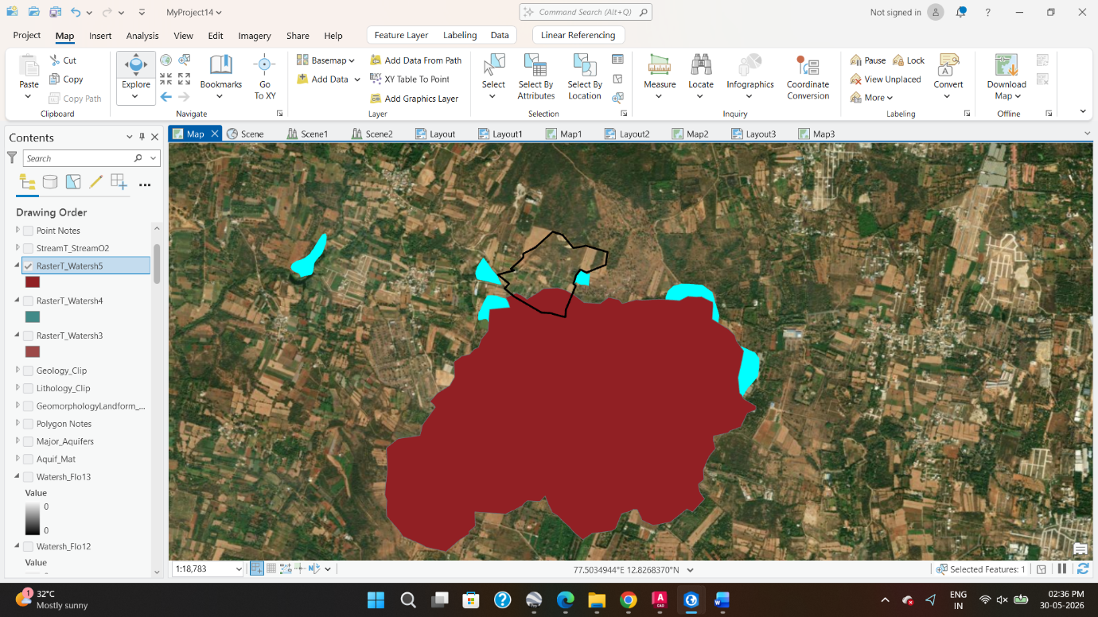
Type: Grey Hornblende Biotite Gneiss ▪ Can be used as a strong foundation rock, construction material

Lake Catchment : 760 Acres
Bottom

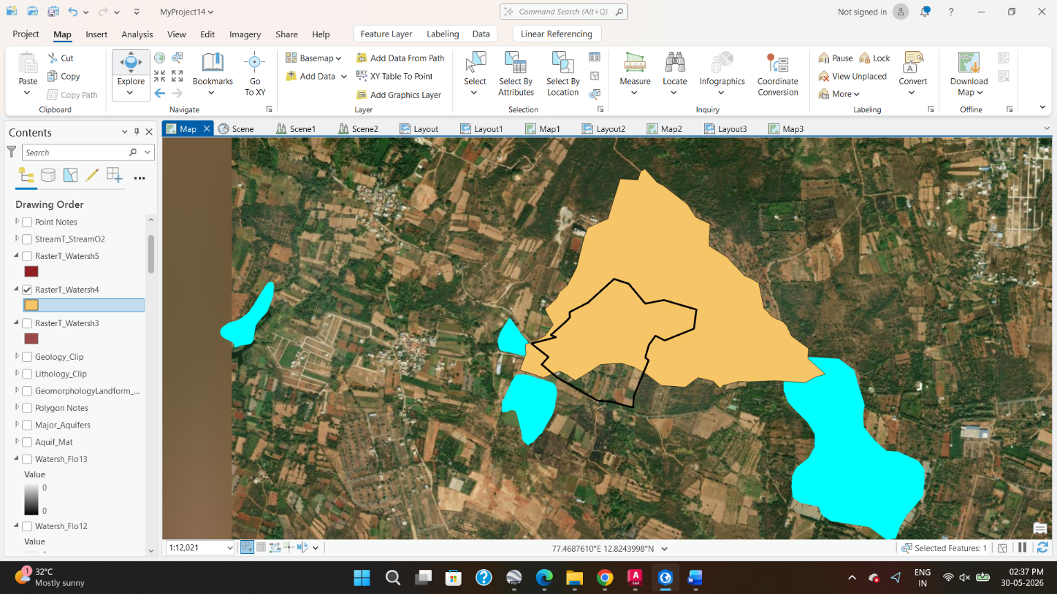
Lake Catchment : 180 Acres
Left

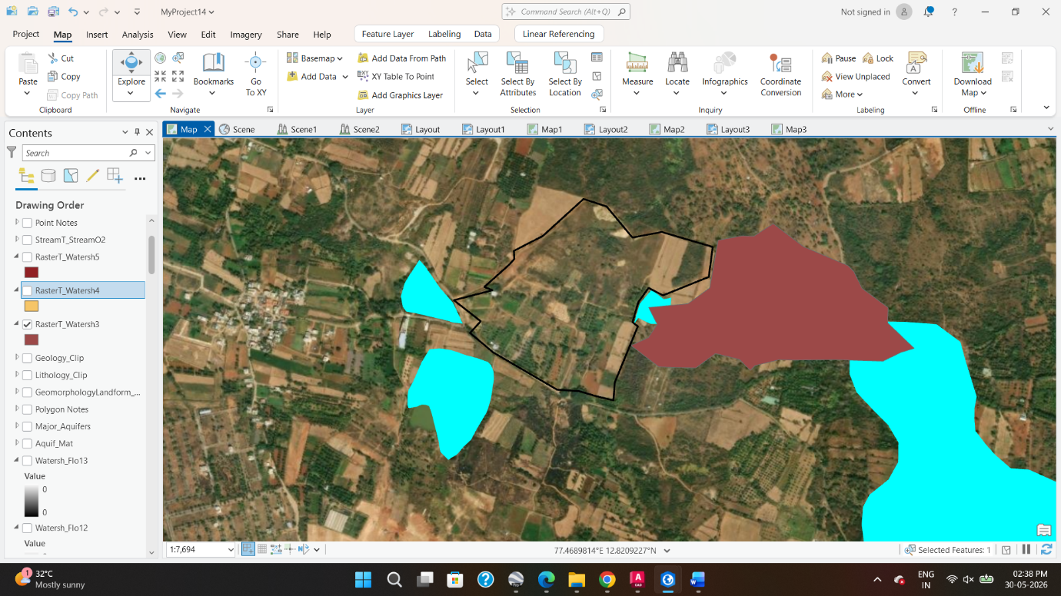

Lake Catchment : 48 Acres

right

